YOUR HEALTHY OPTIONS FROM FARM TO FORK

**FARM FRESH PROPOSAL**

*with over 30 local stores!*

Prepared by:

Tech Squad

Prepared for:

Steve George

DATE: July 18, 2022

# Table of Contents

1.Description 3

2. Target audiences 3

3. Project Details 5

4. Proposed Design Solution 6

Home Page: 6

Product List View Page: 7

Product Detail Page: 8

5. User Personas/Use Case statements 9

Admin User: 9

Authenticated User: 9

Guest (Unauthenticated) User: 9

6. Sitemaps: 10

Front-end 10

Back-end 11

7. Server 12

8. Security 13

On the Server: 13

On the Web App: 13

Password Encryption: 13

XSS Protection: 13

CSRF Protection: 13

Authentication: 14

SQL Injection Protection: 14

9. Database 15

10. Value adds 16

11. Revised ERD for Value Adds 17

12. Our Team 18

# 1. Description

Farm Fresh was established in 2014; It delivers fresh and local produce year-round. This local company is famous for its fresh produce, at an affordable price and service provided. Farm Fresh’s main goal is to increase awareness of the local farmers and introduce them to the local people to help them grow their businesses and help people to maintain their healthy lifestyles. Now the company is expanding and starting an online business, hence requiring a new website introducing its products and service. Farm Fresh wants to emerge in the market with a fresh website that is easy to navigate, and that provides a great user experience.

This local store is now starting to expand and provide its online service Canada-wide. It is now planning to deliver fresh produce at a few other locations throughout Canada. The company wants to build its website using the latest technologies which can be maintained easily.

The website will be based on PHP, Vue, and MySQL databases. MySQL database will be used to store all user data, and product data and can be dynamically fetched/stored as required. MVC(Model-View-Controller) structure is being used to keep it organized and easy to maintain.

# 2. Target audiences

Everyone in today’s world wants to stay healthy and fit. The company aims to fit into this modern trend and to provide freshness to as many people as possible. As of now, the company’s main target is to cover the area around the major cities of Canadian provinces and eventually cover small towns as well.

The second target is differently-abled people, who often are not able to visit stores by themselves and would prefer buying groceries online. The website design is made simple though attractive so that people of any age group can access this easily.

The overall target is set to the group of people who are looking for a healthy lifestyle on a reasonable budget by getting it delivered at their convenience.

# 3. Project Details

Our team will maintain time logs and will try to complete the work before delivery deadlines. Our company will try to fulfill all requirements set by the client.

New designs and technology will be applied to customers' user-friendly experience, satisfaction, and easy navigation throughout the website. The website will be made compatible with the latest as well as old technologies so that people from every age group can access it easily. We will also include a functionality where repeating customers can easily access their previous purchases. Links to social media accounts will be included to promote advertisement. Our top-selling products will be featured on the home page of the website.

• Make the website responsive so that it can be used on any device of any screen size. (Desktop, Laptop, Tablets, Mobile)

• The website should also work on almost all browsers that are available in the market and all older versions of browsers except those older than IE 8.

• Users should be able to filter categories of their choice.

• The website will be mainly focused on marketing fresh vegetables and fruits though it will have dairy products as well.

• There will be a feedback form where user can submit their reviews regarding our services and products.

• There will be a form on a contact page where users can connect to Farm Fresh for any queries.

# 4. Proposed Design Solution

# 

## Home Page:

## 

## Product List View Page:

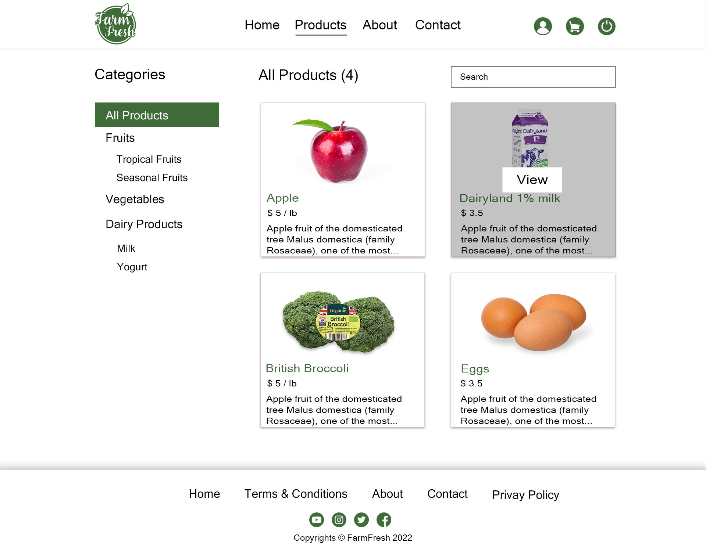

## Product Detail Page:

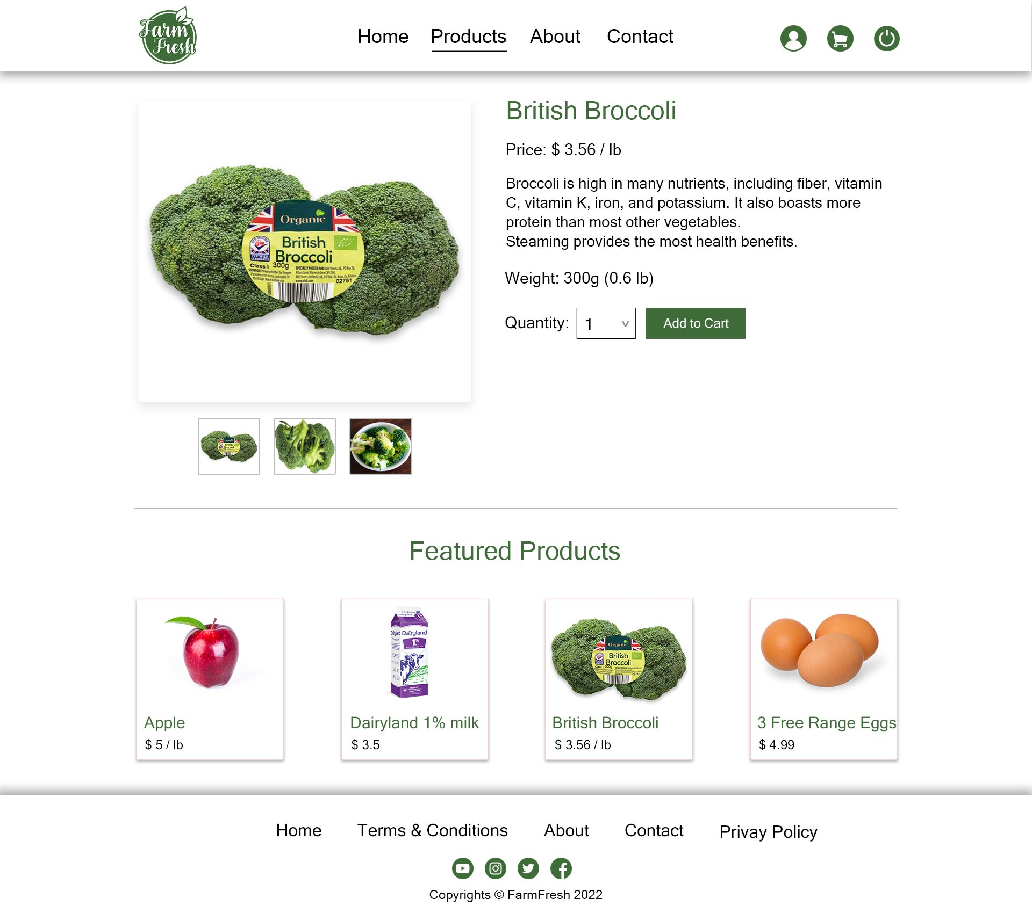

# 5. User Personas/Use Case statements

## Admin User:

Admin has access to the backend of the website. After signing in admin will be landed on the dashboard where he will be able to see aggregate data. Admin can also view, update, and delete products as well as categories. Can also see previous orders that are placed by different users on the orders page. Admin can also see the list of customers who registered with them. Admin can manage orders, view transaction logs, and customer reviews.

## Authenticated User:

Any user can be authenticated user by filling up the registration form with valid data entry and submitting it. They can visit or update their profile. They can use the search bar to search for products. Add products to the bag, and modify their cart. Make an order. See their order list and log out from the website.

## Guest (Unauthenticated) User:

Any user that has not been registered yet, can be considered unauthenticated and can only see the main home page, list view of product, Contact, and About. He/she can use the search bar to search for products and redirect to the products page, add products to the bag, but cannot make an order or visit the profile page. They may ask to register or log in first to access those pages.

# 6. Sitemaps:

## Front-end

## Back-end

# 7. Server

The website is being developed on ubuntu version 20.04.4 and being hosted on team1.uwpace.ca

|  |  |
| --- | --- |
|  | **Version** |
| NPM | 8.11.0 |
| Node | 16.16.0 |
| PHP | 8.1.8 |
| Composer | 2.3.10 |
| Laravel | 9.1 |
| Vue.js | 3 |
| Bootstrap | 5.1.3 |
| MySQL | 10.4.21 |
| Apache | 2.4.41 |

Our project is using a version control system such as Git.

# 8. Security

## On the Server:

* The permissions of the root directory are restricted
* Ensured all .htaccess files cannot be overwritten by Apache (644)
* SSH root access is disabled.
* Ports other than those required by the server (80, 443, 22) are closed by firewall rules.
* Created separate users for each web application and database.

## On the Web App:

### Password Encryption:

Users who are willing to register are required to set the password for further interactions. These passwords are secured and encrypted as we are using hashed passwords to encrypt them, and this method is highly secure in today’s modern tech world. These encrypted passwords are highly unlikely to be decrypted by any outsiders which makes the system trustworthy.

### XSS Protection:

XSS – Cross-site script injections are prevented by using built-in PHP entities to sanitize the data before using this data anywhere else on the website and the browser will prevent rendering of the page, if an attack is detected.

### CSRF Protection:

Cross-site request forgery attacks are prevented by adding CSRF tokens to forms and sessions. Get requests will be used only for view or read-only actions. This will limit the changes that can cause CSRF attacks.

### Authentication:

Different levels of authentications will be provided depending on the level of the user. Three levels are admin- has all access, authenticated- can access pages and details of the products, and unauthenticated – can only view five main pages.

### SQL Injection Protection:

To prevent SQL injection, we have separated data from SQL. So that data will never be interpreted as commands by SQL parser. We have used prepared statements and parameterized queries to prevent SQL injection.

# 9. Database

# 10. Value adds

The feature which adds value to the functionality is “Reviews”. Where users will be able to provide their reviews about the product. User can share their experience regarding the product they have used.

Reviews are related to two entities of the database. Users and products, where users can write multiple reviews about the product, and the same product can have multiple reviews from users so that other customers can take advantage of this feature for purchase.

Admin at the backend, can view all the reviews related to a particular product and can take action accordingly.

# 11. Revised ERD for Value Adds

# 12. Our Team

All team members have equal contributions in programming and designing the database as well as designing the look and feel of the website from a customer perspective.

Here is a brief description of our team, and a description of the primary role served by each team member.

## Pulkit Bhardwaj:

He will be working on graphic designing and responsible for gathering all data (images, content) required for the project. All the tasks related to modules created in Trello will be tested by him.

## Sargam Sanghani:

She will be responsible for designing the front end of the website. Every other team member’s work related to the front-end will be approved by her.

## Pravindra Singh:

He will be responsible for creating and managing the database. Additionally, he will be handling database queries.

## Dhara Patel:

She will be responsible for managing the entire project, assigning the work, and making sure that all deliverables are gathered on time.

## Bakhshish Singh Dhillon:

He will be responsible for maintaining git (version control), and all merge requests will be approved by him. He will manage all the server-side requirements.